 | 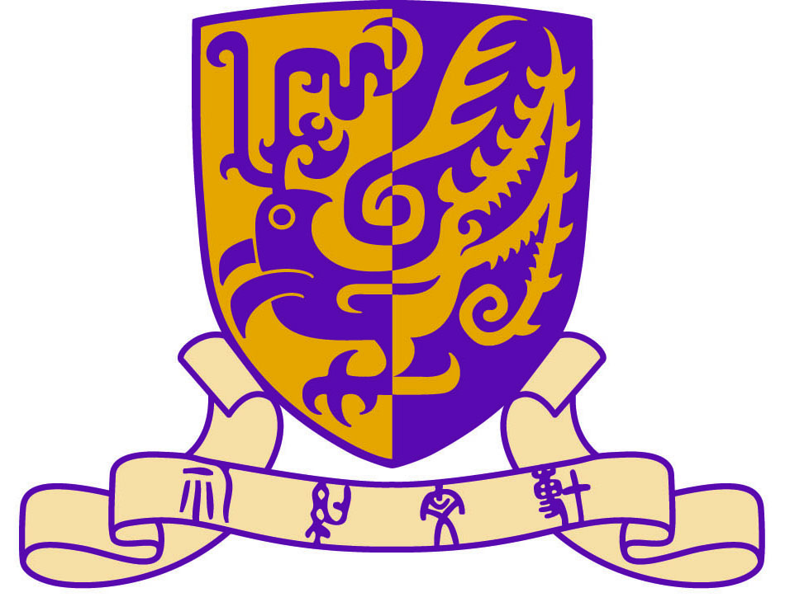 | 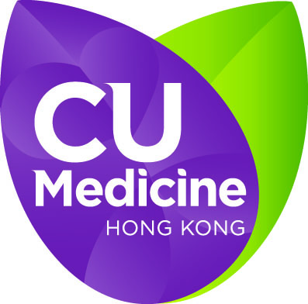
BRAIN 2015 (The 12th Asia Pacific Multidisciplinary Meeting for Nervous System Diseases)
6-7 February 2015 - Hong Kong
http://www.mect.cuhk.edu.hk/brain2015
Registration Form
The fields below with asterisk ( * ) must be filled in.
*Date(s) to Attend
 |  | 6 February 2015 (Friday) |  | 7 February 2015 (Saturday)

Information of Delegate
*Title: | Professor Doctor Mr. Ms. Mrs.
*Family Name/ Surname: |  | *Given Name/ First name:
*Occupation: |  | Department:
*Institution:
*Mailing Address:
*Country:
*Tel: |  |  | Fax:
*E-mail:

*Registration Fee
Category 1 |  | Hong Kong Neurological Society  Hong Kong Neurosurgical Society  International Academy of Pathology, Hong Kong Division  Students/Staff of The Chinese University of Hong Kong  Staff of Prince of Wales Hospital / Hospitals in New Territories East Cluster (NTEC) | Free
Category 2 |  | Alumni of The Chinese University of Hong Kong  Students of other universities in Hong Kong  Staff of other hospitals of Hospital Authority | HKD 300
Category 3 |  | Overseas delegates / Others | HKD 1,200/ USD 150

BRAIN 2015 (The 12th Asia Pacific Multidisciplinary Meeting for Nervous System Diseases)
6-7 February 2015 - Hong Kong
http://www.mect.cuhk.edu.hk/brain2015
Registration Form

*Payment Methods

Cheque (For local registrants only)
Please prepare a cheque made payable to “The Chinese University of Hong Kong” and mail it to:
Division of Neurology, Department of Medicine and Therapeutics, The Chinese University of
Hong Kong, 9/F Lui Che Woo Clinical Sciences Building, Prince of Wales Hospital, Shatin, N.T., Hong Kong.
Please write down your name and contact number on the back of the cheque.

 | Credit card
 | Visa | Master
Cardholder’s Name |  |  | Amount in total: (HKD only)
Card Number |  |  | Expiry Date (dd/mm/yyyy)
Signature

